**A GLOBAL Co2 EMISSION ANALYSIS**

**PROJECT REPORT TEMPLATE**

1. **INTRODUCTION**
   1. **overview**

**Description about Co2 emission**

Co2 emission are emissions stemming from the burning of fossil fuels and the manufacture of cement they include carbon dioxide produced during consumption of solid, liquid and gas fuels as well as gas flaring.

* 1. **purpose**

The carbon in Co2 can be used to produce fuels that are in use today, including methane, methanol, gasoline and aviation fuels.

1. **PROBLEM DEFINITION & DESIGN THINKING** 
   1. **Empathy Map**

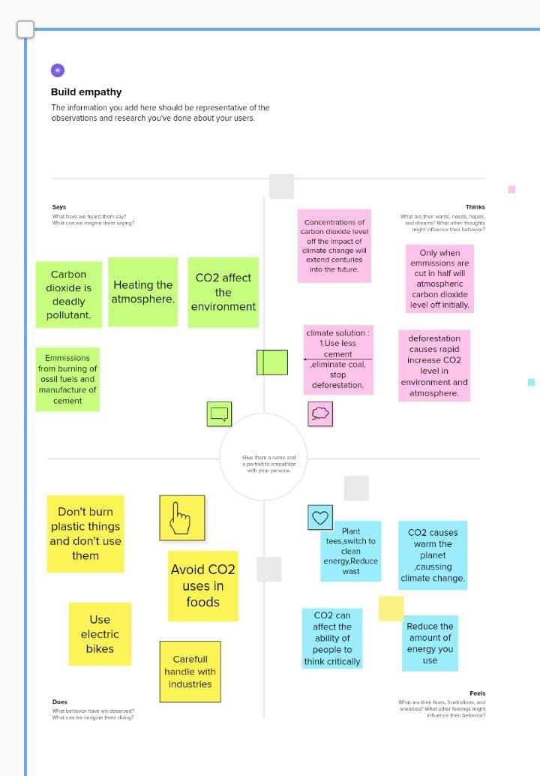

* 1. **Ideation & brainstorming map**

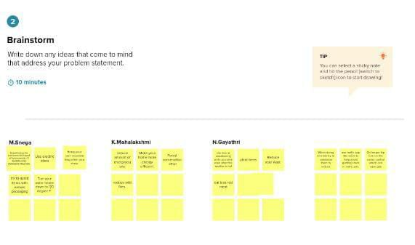

1. **RESULT**

Findings

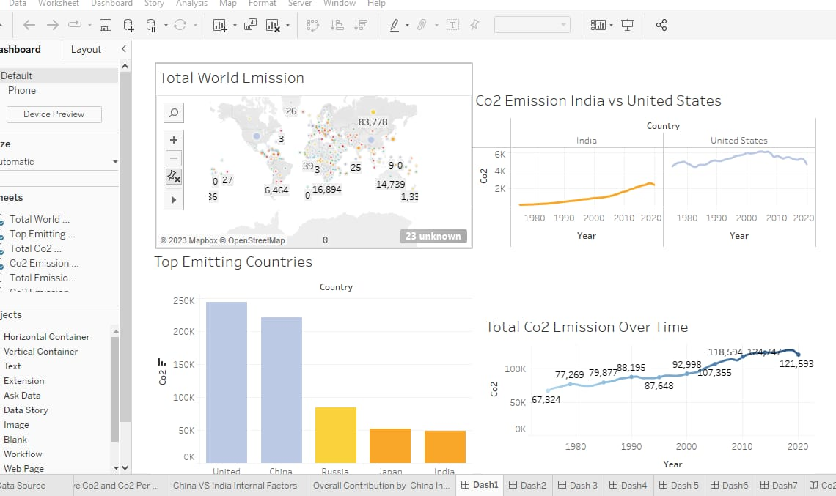

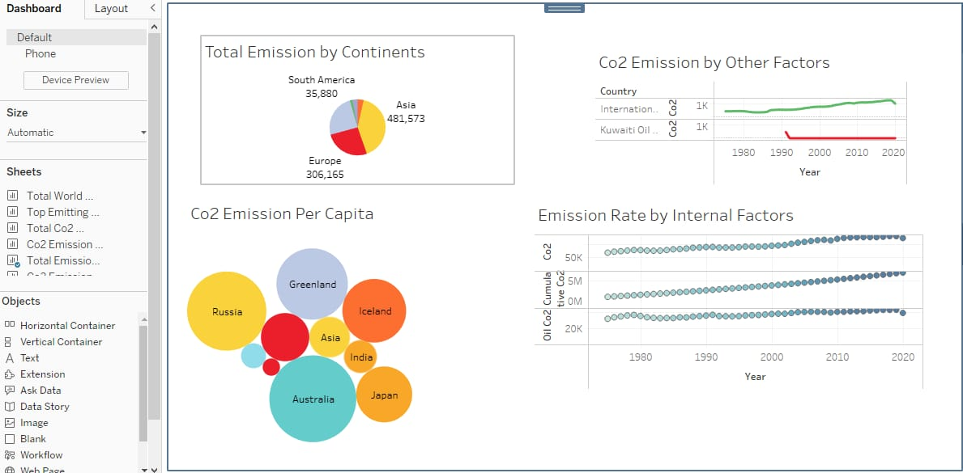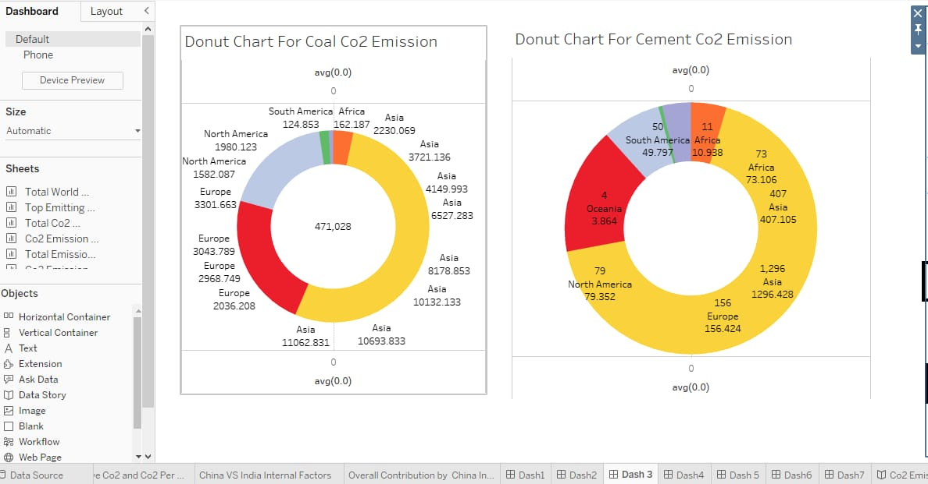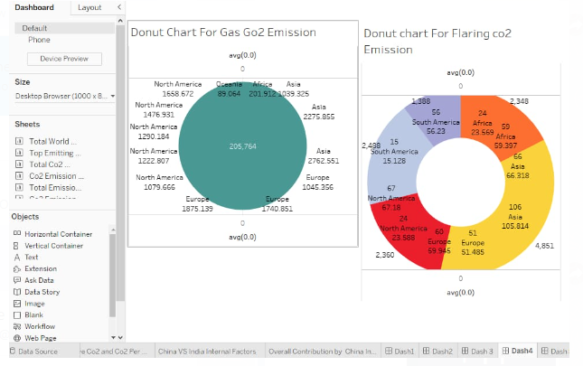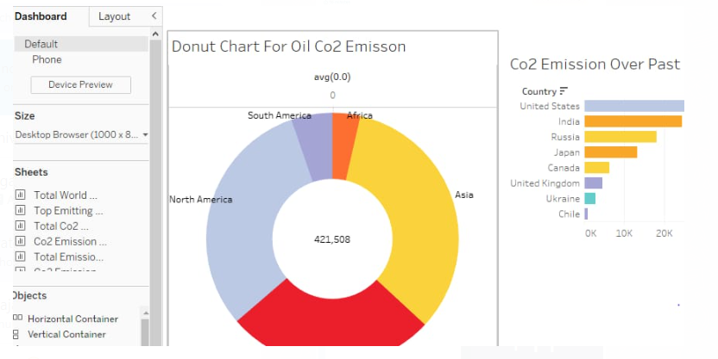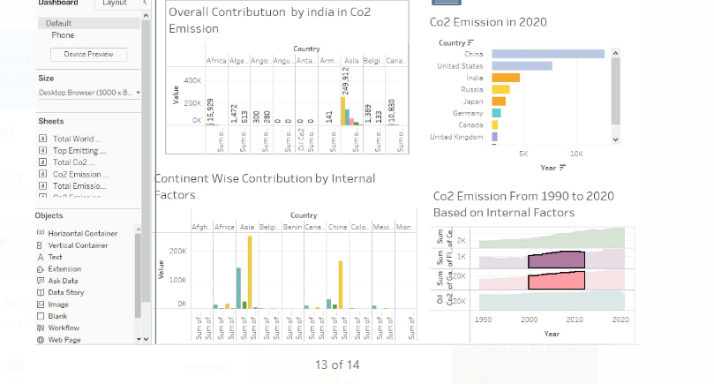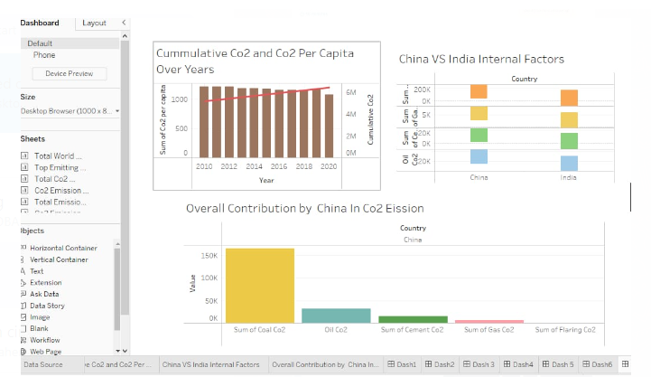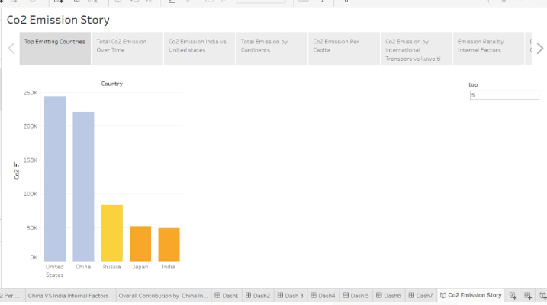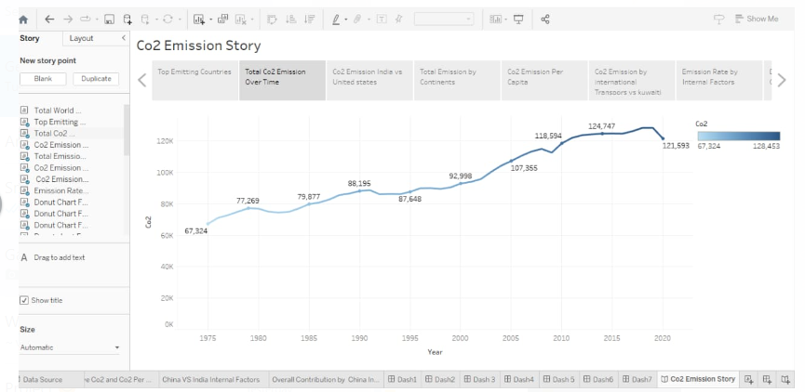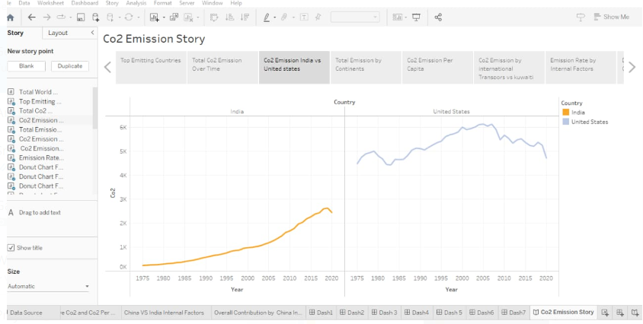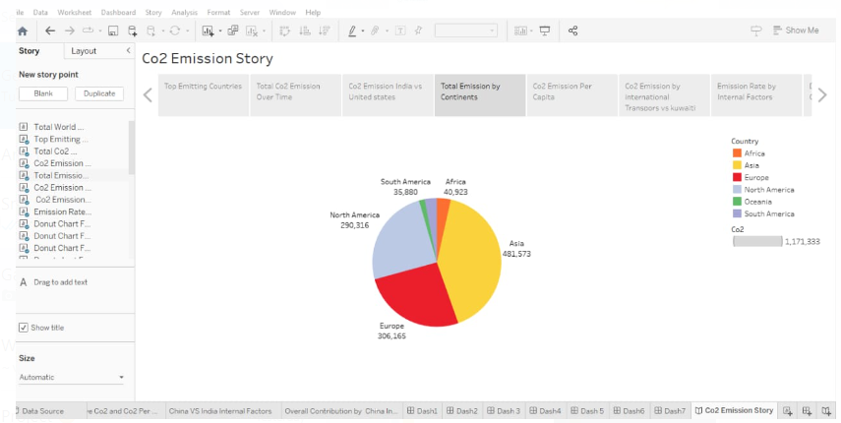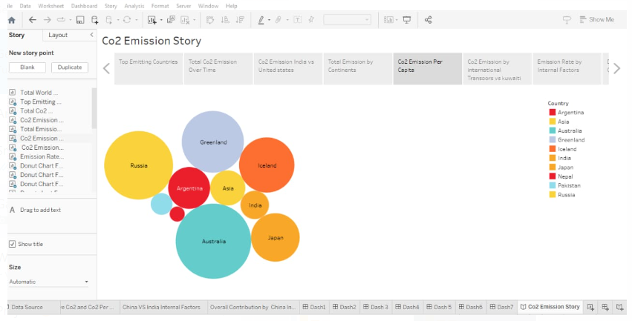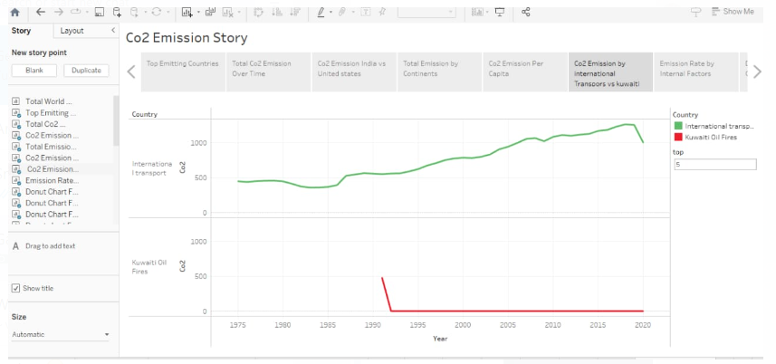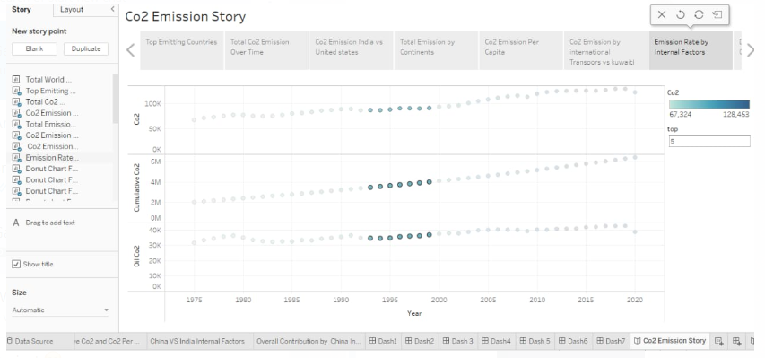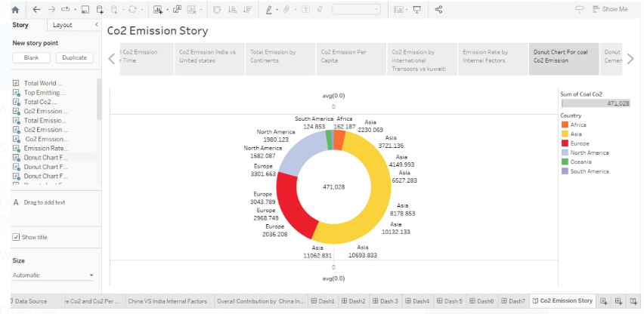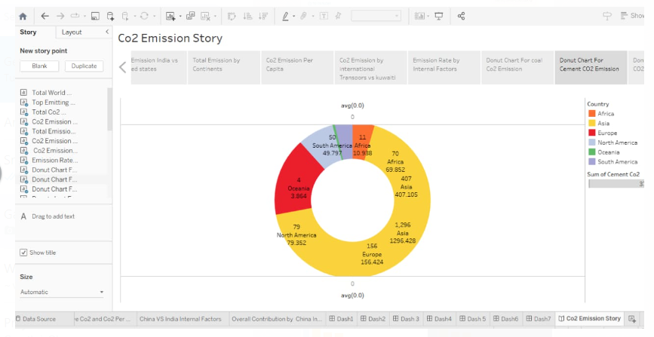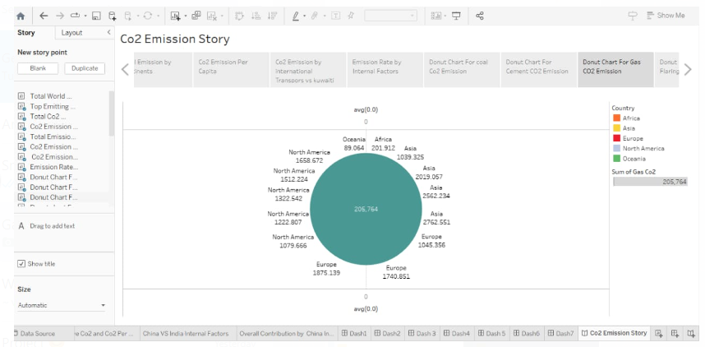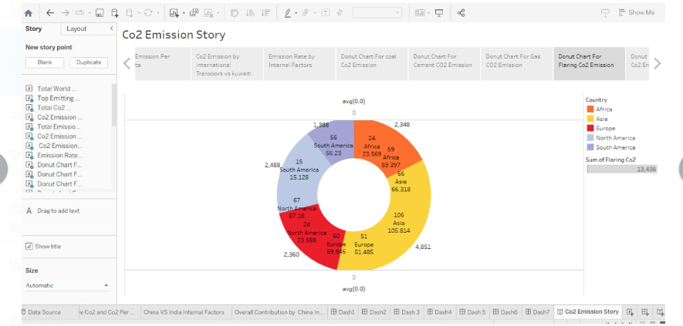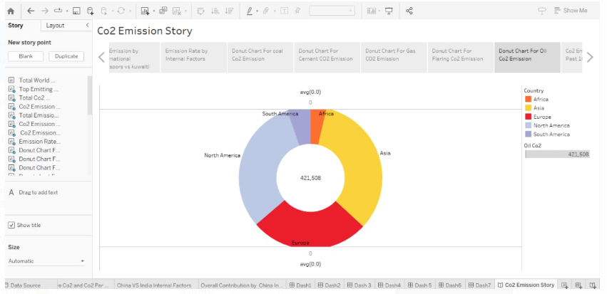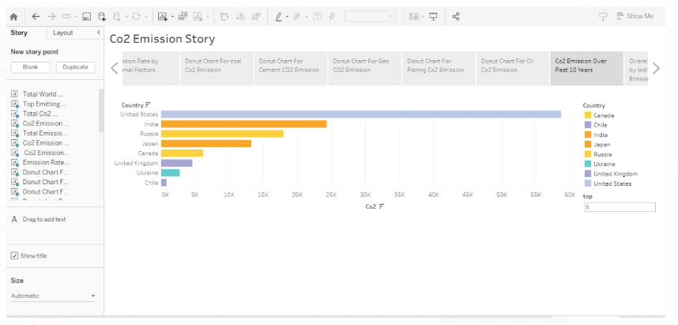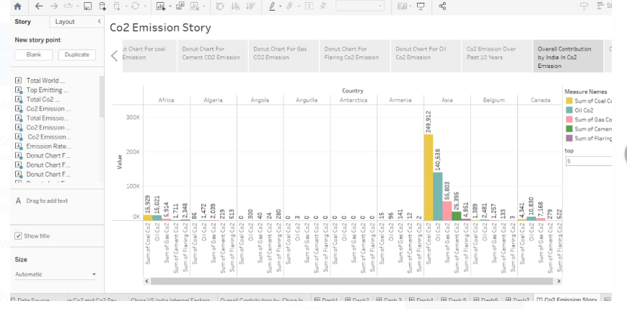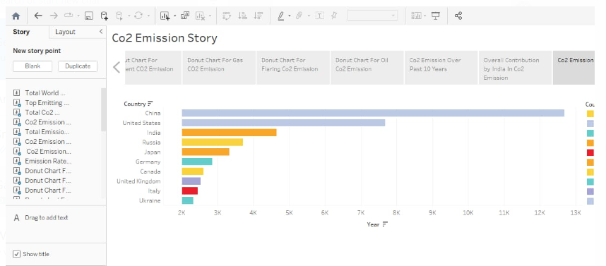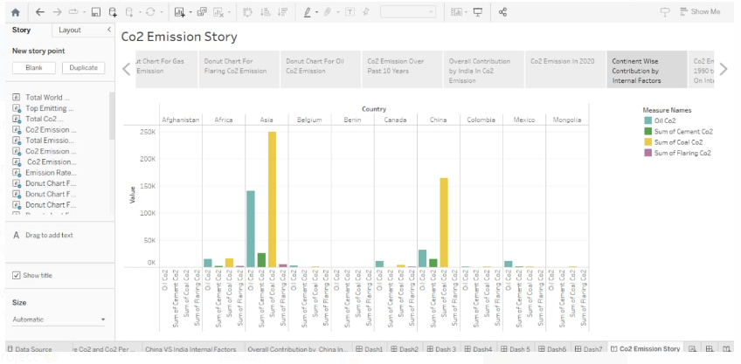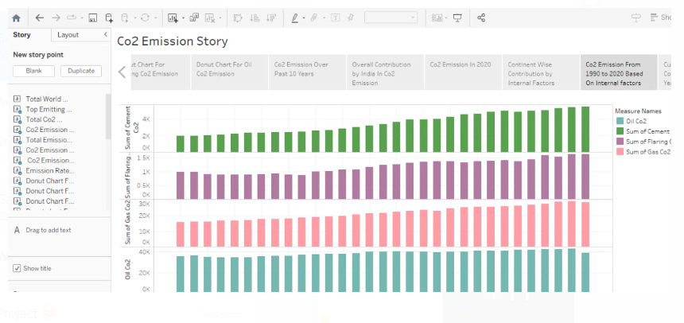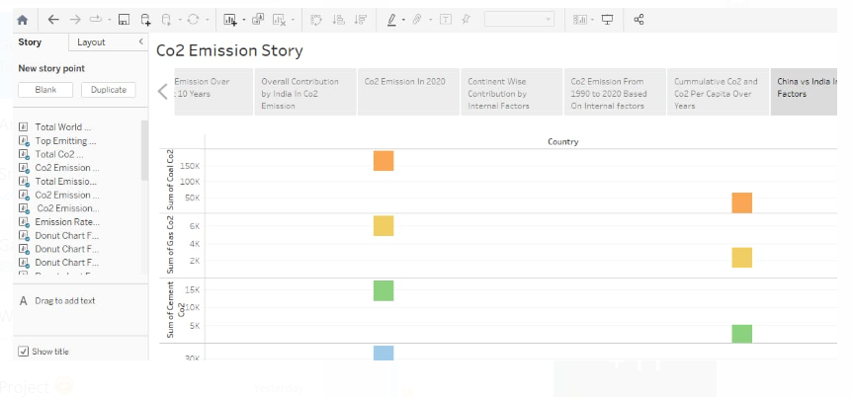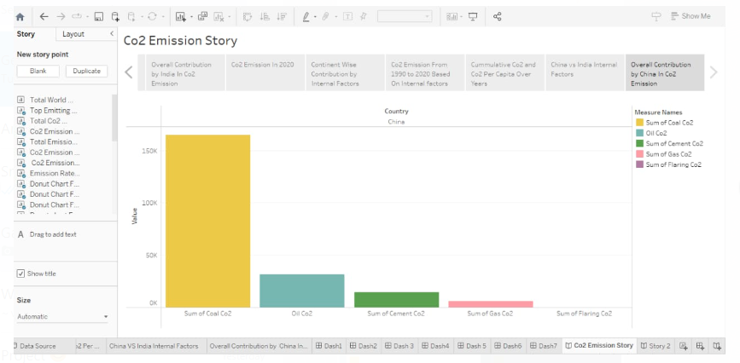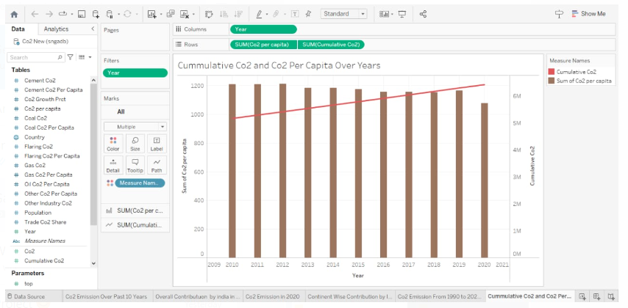

**4 ADVANTAGES AND DISADVANTAGES**

* ADVANTAGE

1. The Need for Co2 Piping to Transport the gas to undergrount storage sites.
2. Allows the use of renewable energy and optimal storage sites.

* DISADVANTAGE

1. Can’t Capture at large, point source emitters (e.g. power plants), as it is likely to be more efficient and cheapper to capture and store carbondioxide from more concentrated streams.
2. **APPLICATION**

Reducing Our Carbon Emissions Helps Reverse the Impact of Global Warming overall, But More Specifically, Benefits Overall Air Quality.

1. **CONCLUSION**

Our articles and data visualization rely on work from many different people and organization.